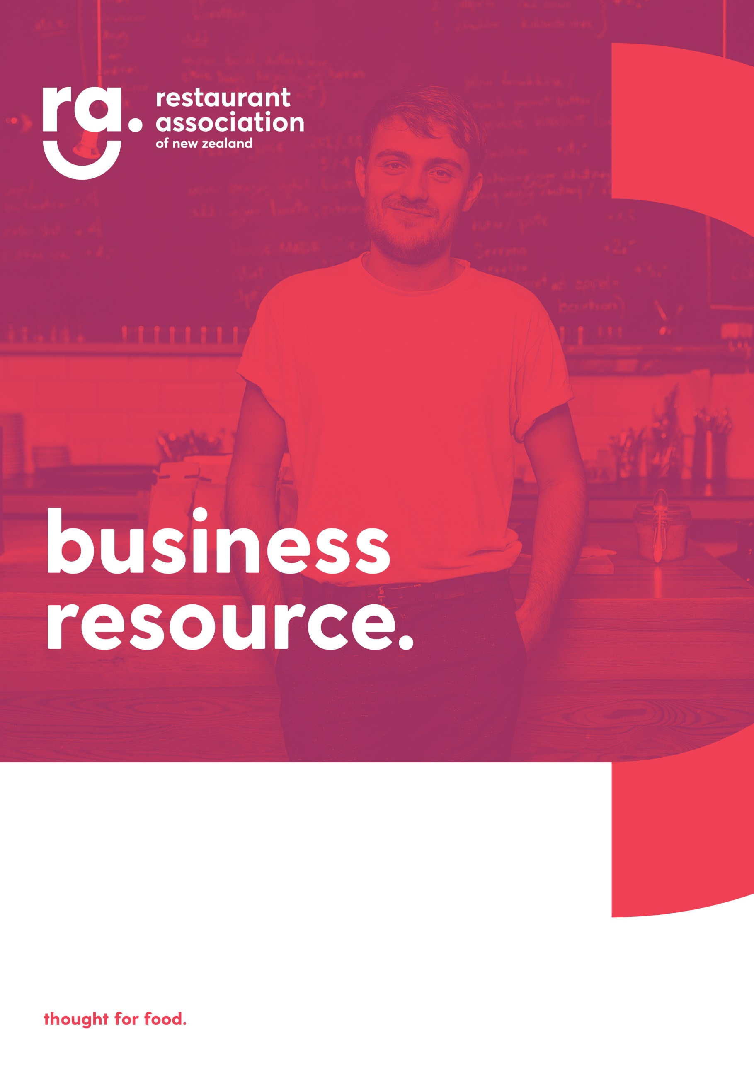
v
Communicating with your customers

COVID-19 Media Survival Toolkit
Make sure you put your customers minds at ease by being proactive with your communication.
- Put up a notice on your website and social channels. Use the template below as a guide
- Have a customer database? Great – send all of your customers an email to let them know what measures you have taken
Social media / Email / Website communication template
“IMPORTANT UPDATE
You may have heard in the news that a confirmed case of COVID-19 dined in our restaurant/café/bar on INSERT DATE.
We were contacted by the Ministry of Health on INSERT DATE to notify us and have been working with them to ensure that all of the guidelines are followed.
Since the person dined here, we have completed a deep clean and the staff member/s that served this customer are self-isolating for a period of three days.
ADD IN ANY OTHER RELEVANT INFORMATION
We welcome any questions you have so please do contact us via XX
We want to reassure you that our restaurant is completely safe for both dine in and takeaway. Thank you for supporting us during this time.”

When the media come knocking
It can be distressing when you are the subject of media scrutiny but with some deep breaths and a bit of preparation, you can actually turn this challenging situation into a positive opportunity for your business.
Follow this guide below to help you manage the situation when it arises:
- The Restaurant Association has a dedicated PR person on the team who can help to coach you through any media interest. So call us first so we can help you to put a plan into action
- Take control of the situation. It’s generally best to help the media as best you can but this doesn’t mean that it shouldn’t be on your terms. Take their name and the media outlet they are from and let them know when and where you will be free to speak to them
- A media interview can take place over the phone, via email (written) or in person either in their studio or most likely at your establishment. TV will want to do the interview outside or inside your establishment whereas radio will want to record you down the line so find a quiet spot with a good reception
- Radio or TV? Find out if the interview is going to be live or not.
- Make sure that the media stick to your guidelines. Ask them not to block the entry from guests or staff arriving, and to speak to you before speaking to other staff for example
- Brief your team and let them know that they may be contacted by a member of the media and make a decision between you on who should be able to front interviews on behalf of the business. Brief non spokespeople to take the media’s contact details and assure them that they will pass it on to the business spokesperson. Do make sure that you return those calls as quickly as you are able
- Find out upfront what they would like to cover in the interview. This will help you to prepare
- Off the record? There’s no such thing! Remember that the media can quote anything you say so make sure you are on message the whole time and do not say anything you wouldn’t expect to see published
- Prepare! Think about what you want to say. Make your points, clear and succinct and rehearse them. Stick to the 4P’s
  - Principle – what is the point that you want to make eg. Our industry plays a vital role in our communities
  - Proof – why should this be believed?
  - Personalise – put yourself in the shoes of the audience/listener, use your own experience or that of your audience to make the point or use topical information/news to hit home your point
  - Preparation – all interviews need careful preparation and don’t worry about having notes on a piece of paper for the interview itself (except telly of course!)
- Take control of the interview
  - Ask the first question
  - STOP and repeat
  - Beware the reporters pause (they stop talking to make sure you keep going, so stop when you’ve made your point)
  - Remember your key messages
  - Bridging techniques can be great for tricky questions. Use one of these to transition back to a key message
    - “the important point here is …..”
    - “it’s not a question of …… it’s about this”
    - “What I can tell you is this….”
- Use it as an opportunity! An interview is a great way to set the record straight, inform your customers and get some publicity at the same time
Copyright © 2020 Restaurant Association of New Zealand Inc. All rights reserved. No individual, party, entity is permitted to share, adapt or reuse this work without the consent of the Restaurant Association of New Zealand Inc.

