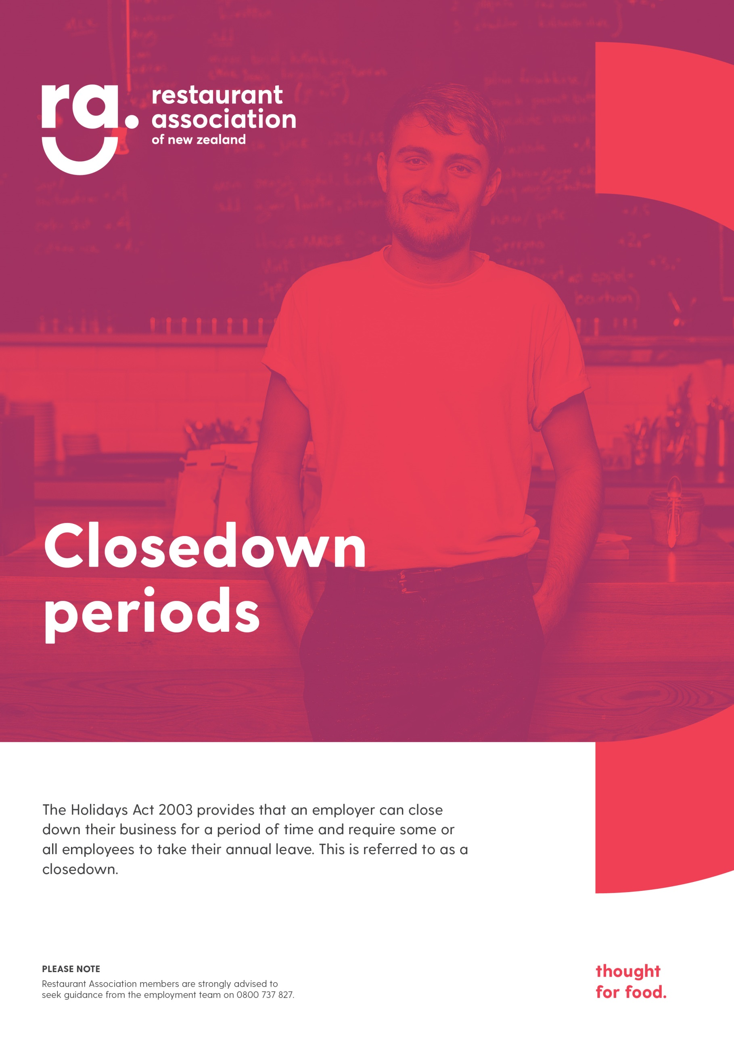
[PLEASE NOTE. Restaurant Association members are strongly advised to seek guidance from the employment team on 0800 737 827 if you have any employment questions.]
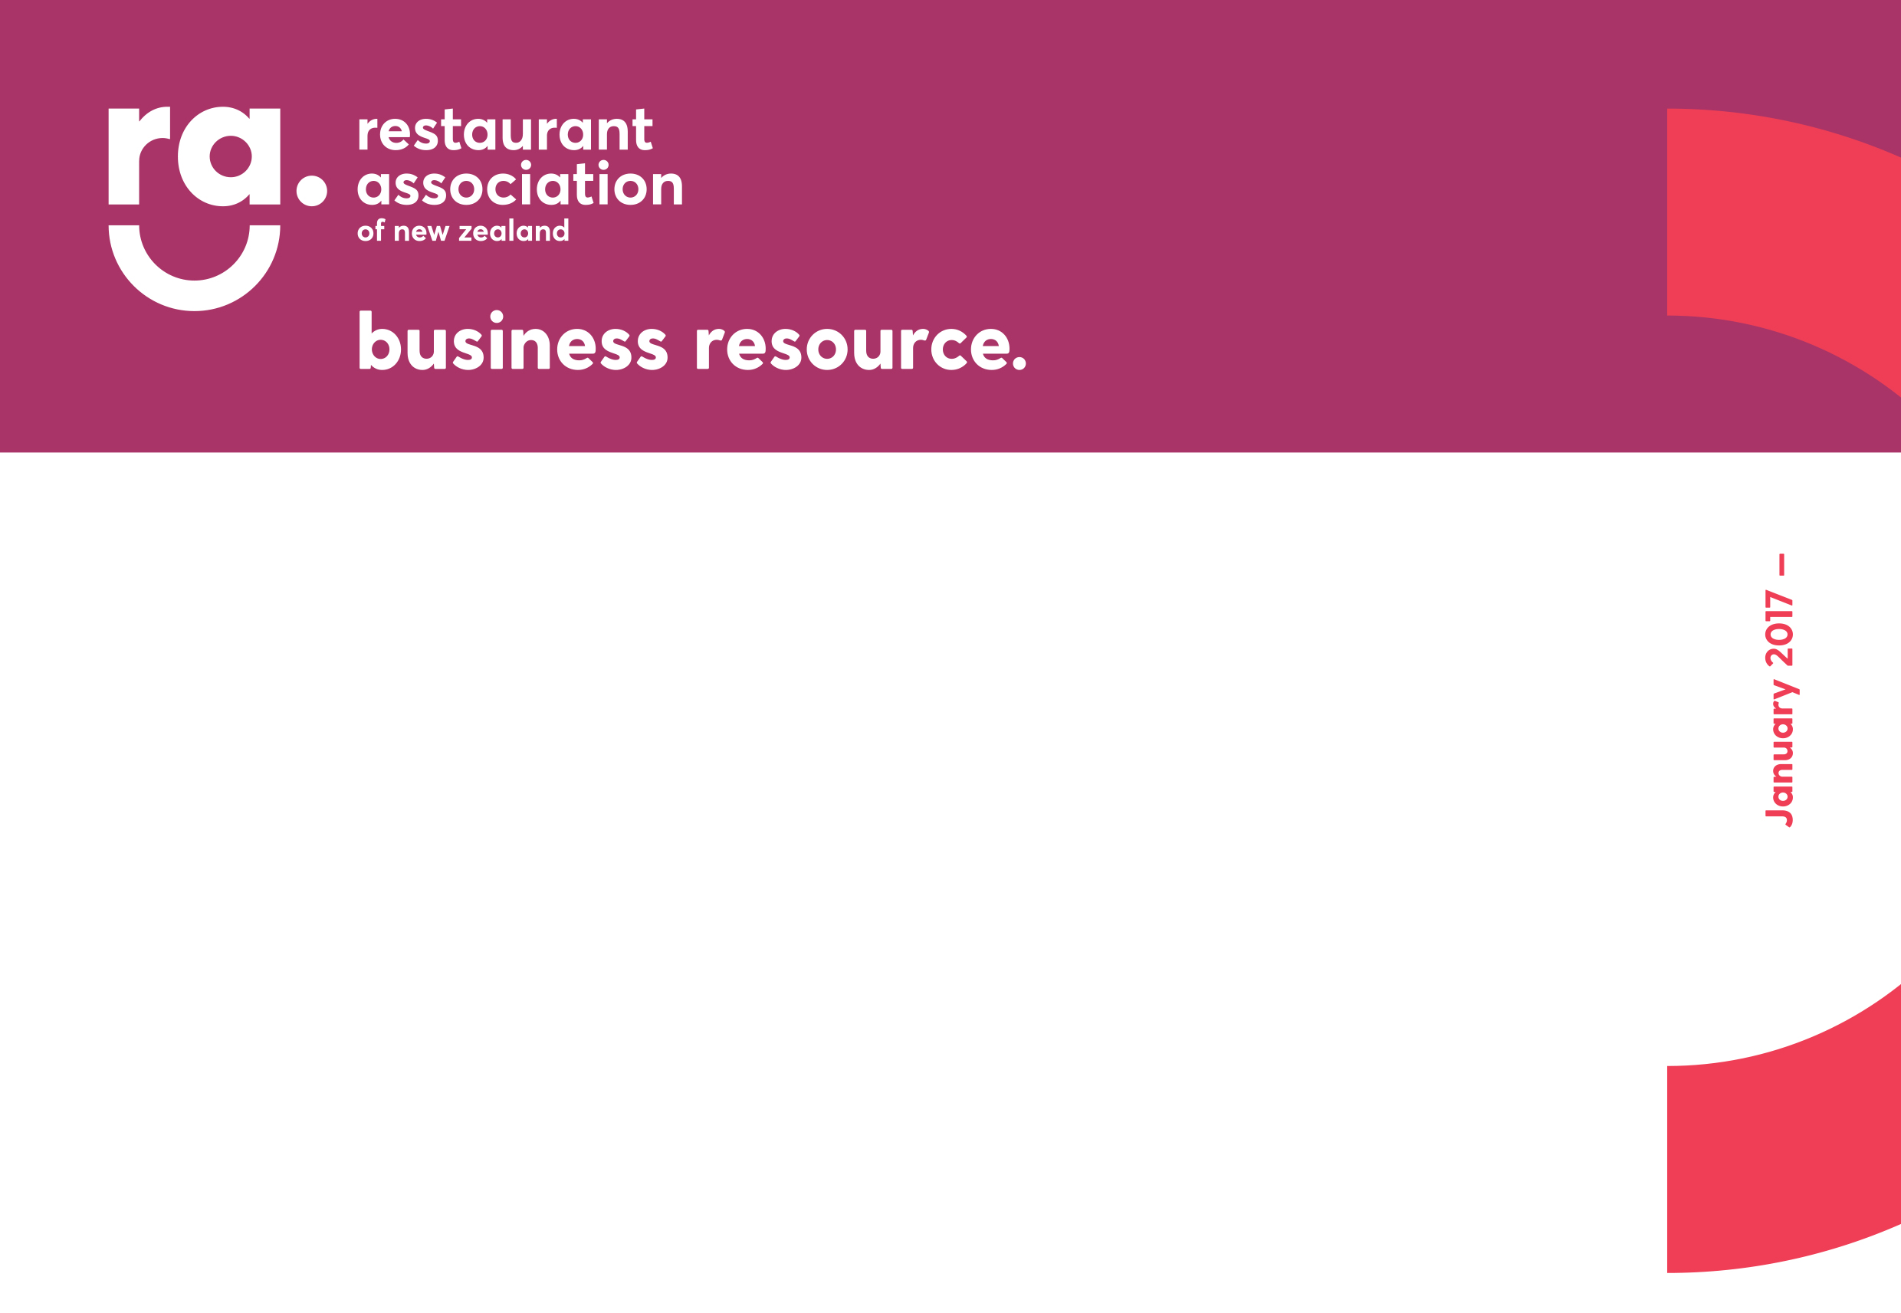
December 2019
Typically, a customary closedown happens over Christmas and New Year, but it does not have to. A regular annual closedown might occur during the year if there is a need; such as at the end of a particular season.

Employers do not have to close the entire workplace and they may have a different closedown period for different parts of the business.

Requirement to take annual leave
If an employer chooses to close for a customary annual closedown, they can require employees to take annual leave, even if the employees do not have enough leave to cover the break. If the employee’s annual leave entitlement does not cover the entire period of the closedown, the employer and the employee can agree that the employee take some of the closedown period as annual leave in advance.

Employees who have an entitlement to annual leave at the time of the closedown i.e. they have been working for 12 months or more, will be paid their annual leave during that period.

Where the employee has not worked continuously for 12 months since commencement of employment or since they last became entitled to annual leave, they will not be entitled to annual leave at the time of the closedown. The employer and employee can agree that the employee takes annual leave in advance or take unpaid leave.

However, if no such agreement is reached, and the employer wishes for the employee to observe the closedown period, the employee is entitled to a payment of 8 per cent of their gross earnings since commencement of employment or since the employee last became entitled to annual holidays. Furthermore, the employee’s anniversary date must be moved to the date on which the closedown period began. However, to avoid having a different date in each year on which the employee becomes entitled to annual holidays, the employer may nominate a date which must be treated as the date on which the closedown begins provided that the date nominated is reasonably proximate to the actual beginning of the closedown period.
Requirement by employer to provide notice
An employer is required to give at least 14 days’ notice of the requirement to take the annual holidays or discontinue the work. We suggest organising a meeting with all staff well before the 14-day notice period to advise them of the closedown and to discuss any concerns they may have. Please refer to the template letter in the Appendix. This letter should be given to staff to confirm a closedown period.

It may also be useful, if you do have a customary closedown period, to include a clause in your employment agreement. Please refer to the sample clause in the Appendix.

Public holidays that fall during a closedown
It should be noted that a public holiday that occurs during an employee's annual leave (taken during a closedown) must be treated as a public holiday and not as part of the employee's annual leave. The employee is entitled to be paid for a public holiday if the holiday would otherwise have been a working day for the employee.

Appendix
Suggested clause for employment agreements
The employee recognises that this operation closes over the Christmas / New Year period for a customary closedown. You will be given at least 14 days’ notice of the commencement of the closedown period.

There will be no remuneration payable during this closure, although you may be paid where it is offset against annual leave entitlements that may be owing.

Letter to advise of an annual closedown period

Please note that the following letter template requires you to the complete details that pertain to your particular situation. You will need to complete the fields in [brackets like this].

[Date]
[Name of business legal entity] T/A [Trading name]
[Business Address]
[Employee’s full name]
By email: [Employee’s email address]

Dear [Employee’s first name]

Annual closedown
Our annual closedown will be from [date] to [date]. The last day of trading will be [date] and we will reopen on [date].

If you have an annual leave entitlement, you will be required to take this during the period of the closedown. If you do not have an annual leave entitlement, you are welcome to request annual leave in advance or unpaid leave. Please contact us to discuss which option you would prefer.

Please let us know if you have any questions.

Kind regards

[Name]
[Position]
[Company]

